**Book Your Alderley Edge Tennis Camps on-line through our new App**

We are delighted to announce the launch of a new App for Alderley Tennis

**You can now book summer camps from your phone. Your place(s) on the camp(s) will be secured once you have booked your place(s) and completed your payment.**

We will be developing the app further for other activities.

Download the App using the following links.

[Link to Alderley Edge Tennis app for Apple Users](https://apps.apple.com/gb/app/alderley-edge-tennis-club/id1571433495)

[Link to Alderley Edge Tennis app for Android Users](https://play.google.com/store/apps/details?id=app.activitypro.alderleyedgetennisclub)



You sign up as an adult and then can add further members of your family. Please ensure you **only tick the ‘Member’ option** if you are a **member of Alderley Edge Cricket Club - Tennis Section. Note - If some of your family are members and some non-members, then add your family members, and then please email Ruth Samuels (**[**samuels.ruth@googlemail.com**](mailto:samuels.ruth@googlemail.com)**) BEFORE you make any bookings and she will adjust the membership settings.** We will be on hand to do this very quickly on the launch date:

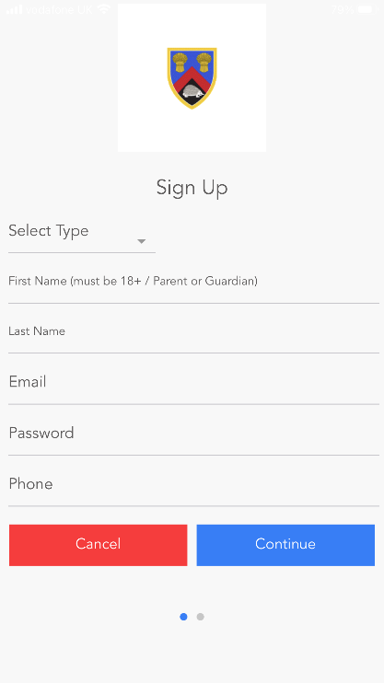 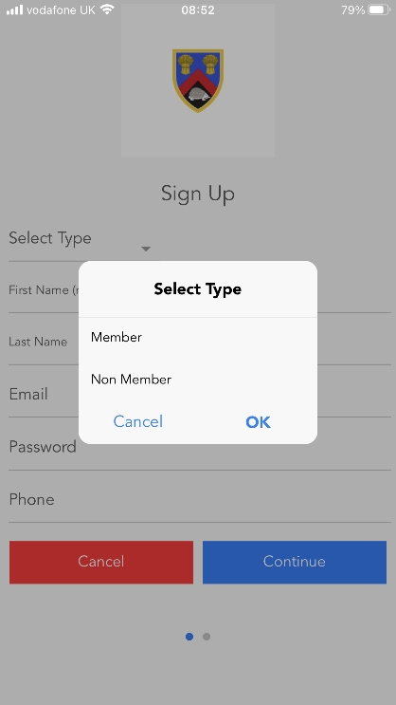

Add your family Members as follows:

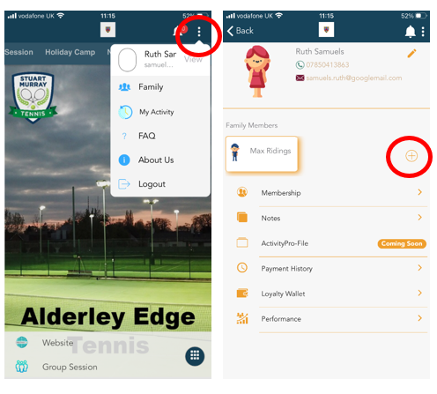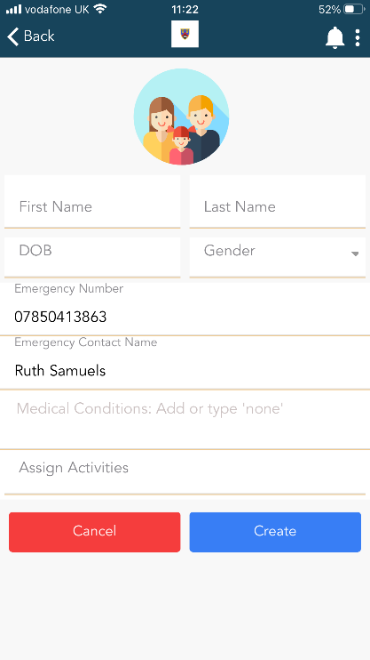

And if you or your family’s membership status changes at any point, then please contact us and we will change your status on the App for you

**To Book a camp** - choose the holiday camp tab and choose the camp. Then select the attendee - it is important to select the attendee before you select the dates. Select the dates and enrol. Make all bookings for all members of your family. [Here is a video to show you](https://youtu.be/h1sum5_iUTg)

Then go to your basket and pay.

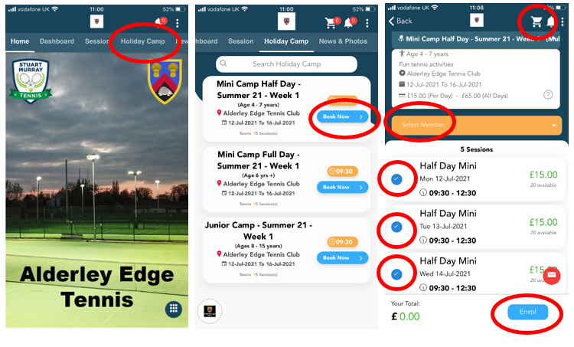

Sessions booked will be shown on your dashboard. Click on the individual booking to see the days booked:

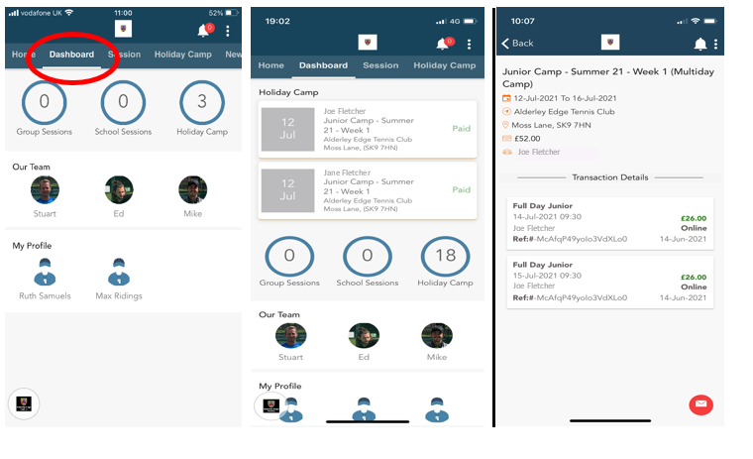

Please contact Stuart Murray (Head Coach) - info@stuartmurraytennis.co.uk - if you have any questions about the camps